Beekeeping 101 – Seminar
Introduction:
I’m Brenda Renfroe. I’ve been a beekeeper for over 7 years. I started backyard beekeeping because I love to garden, and for years I never saw a honeybee in my yard. I did some research and started by reading Beekeeping for Dummies, by Howland Blackiston. I purchased my first package of bees from Bee Commerce in Newtown, owned by Leslie Huston. Leslie is a master beekeeper and has been beekeeping for over 20 years. I worked at her shop for 4 years during the busiest beekeeping time and gained incredible insights into beekeeping. When Howland updated his book 2 years ago to the 5th edition, I was part of his research team.

I am also a participant in the Penn State University EPIQ program. The goal of the program is to foster beekeepers to rear strong queens and bees that can thrive in the environment of the
Northeast, mostly through instrumental insemination. The program leaders are Penn State
Extension Educator Dr. Robyn Underwood, and Center for Pollinator Research Apiarist Kate Anton.

I mentor new beekeepers in the area, but joining a local Beekeeping club usually puts you in contact with Mentors in your area. These clubs also offer Bee schools where you can learn beekeeping at different levels. Membership is usually inexpensive.

Connecticut Beekeepers Association
http://ctbees.org
Eastern Connecticut Beekeepers Association
http://myECBA.org
The Backyard Beekeepers Association
http://www.backyardbeekeepers.com/
Beekeeping is a lifelong learning experience and each year I learn new ways to bee keep. I originally had 1 hive which lived over the winter, then 4, then 7, then 13 and I am now up to 29 colonies. I now have 21 hives in my backyard. I manage several more at Henny Penny Farm in Ridgefield. I really enjoy beekeeping!
Not all of them will survive the winter. I believe that the strongest will overwinter and survive mite infestation levels which is the number one reason most bees die.
BEES: You should order Bees now as they will sell out by March. Packages arrive about mid April. NUCS may be a little later because the bees have a bigger start than a package. Package bees need to draw out comb and be fed right away. For NUCs, the queen is already laying, and the comb is drawn out.
- Packages or NUCS can be purchased from local beekeepers or shops. Package bees run about 175. It contains a box of around 10,000 bees and a queen that is caged inside. The box usually has syrup inside to feed the workers as they travel.
I don’t suggest getting packages shipped. The stress factors are variable temperatures, what if it is gets delayed?
- NUCS are small colonies with about 10 – 15,000 bees, a queen and her brood, eggs, larvae and capped brood (2-3 frames). The NUC box usually has 1-2 frames of nectar and pollen. The total number of frames is 5.
EQUIPMENT:
- You will need a starter kit or a complete hive with most of these components:

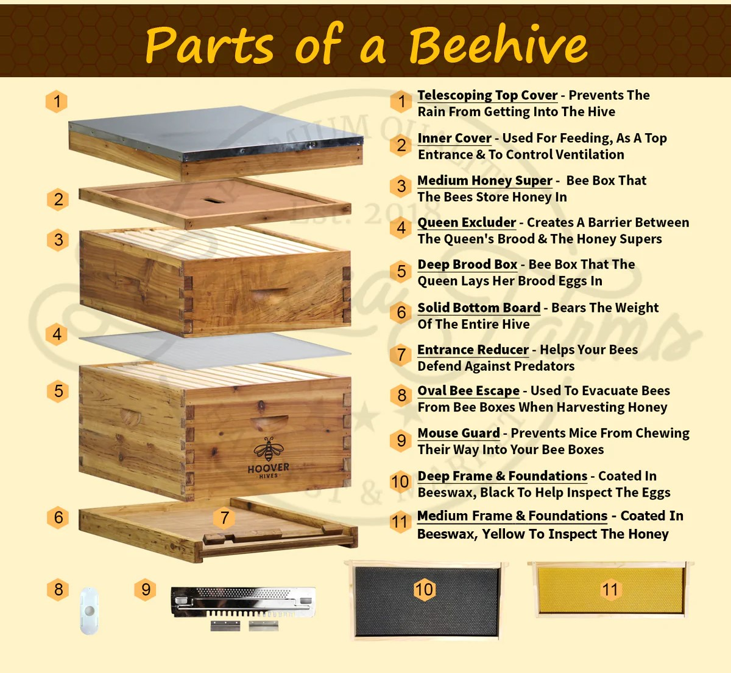

Where to get hive components? Internet shops like Mann Lake, BetterBee; local shops like Agway and Bee commerce. There are variances in type of some of the pieces. Some beekeepers prefer screened bottom boards. It allows grooming bees to drop varroa mites off and the mites fall through the screen unable to come back inside the hive. Some Beekeepers prefer 8 frame equipment to 10 frame boxes. Some prefer medium boxes rather than deep boxes. It is also important to get a feeder. In frame or hive top or mason jar. Again, lots of choices. I place my hives on concrete blocks but there are other options for stands. Equipment must be painted or stained so that it wears well outside. Have this done well before your bees arrive. The hive should face south or southeast to catch the morning sun.
- You will need a hive tool, smoker, smoker fuel, veil or suit, bee brush, and gloves. Again, there are multiple preferences and options.

Bear Fence:
You will need an electric fence unless your yard is fenced in. I use a Parmak 12 solar but there are dozens of types out there. Agway has a couple here. The Joule output should be greater than .5 If you know you have bears, you can bait the wires so that when the bear touches the food with its nose it will get zapped and learn to stay away.
Beekeeping Timeline:
April/May: bees arrive, install them in hive.
I suggest inspecting them every 7 days. You are watching for nectar and pollen being brought in. Checking that you have a queen and/or eggs. A marked queen is preferred and easier to spot as a new beekeeper. Be sure to keep notes.

Be sure to keep notes on your colony each time you inspect them so the next time you inspect them you don’t have to recall what was going on last time. When you have 22 colonies, it is very useful. I created this in Excel and put on a clipboard. You can use specific apps for monitoring Bees but the thought of putting propolis on my cellphone does not appeal to me.
You can use specific apps for monitoring Bees but the thought of putting propolis on my cellphone does not appeal to me. (Handout sample of inspection sheet)

June/July: nectar flow and swarming. Watch for swarm cells. If your colony is particularly strong, you add supers now.

August: dearth, need to feed them sugar syrup. In my area, we get a very dry spell. I usually feed my bees.

September: more feeding syrup and winter patties and treat for varroa mites.

You should register your bees with the State of CT - The Connecticut Agricultural Experiment Station. https://portal.ct.gov/CAES It is free and the benefits are notifications of any outbreak of American Foul Brood or other diseases. There is a State Inspector who will come and inspect your hives for free.

October: button up for winter, add insulation and/or wraps.

November, December, January, February. No need to inspect them. On warm days, they should be flying to take cleansing flight.

Problems: there are numerous things that can happen. It is best to do some research, take photos to show a mentor and you can also post issues on a Facebook group called BeekeepersOfCT.

Q&A: Feel free to contact Ashley for equipment requests. For other questions you can contact me at brhbuzz@gmail.com or you can visit my website: BriarRidgeHoney.com

